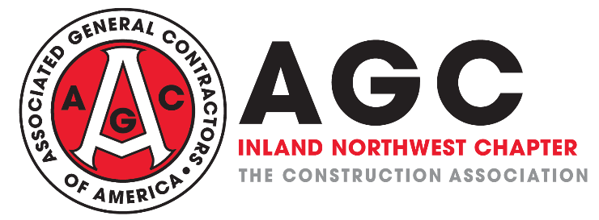

Paycheck Protection Program – Forgiveness Language Clarification

The ISSUE: The Paycheck Protection Program has a clear mission, incentivize businesses to maximize employee retention despite the economic circumstances surrounding COVID-19. The Program does an excellent job of this through loan forgiveness, but for a complicated clause which will confuse and/or disincentivize businesses in conflict with the Program’s intent.

The ASK: Ensure that the Phase 4 COVID-19 relief bill amends the CARES Act to ensure the Paycheck Protection Program allows employers maximum loan forgiveness for employee payroll payments. Specifically, amend the CARES Act by striking Section 1106(d)(2), (3) & (5).

Arguments for doing this:

- As opposed to 40+ states that have deemed construction essential, WA has largely shut our industry down and many contractors are not working, and have no revenue coming in.

- Loan forgiveness is already capped in the CARES ACT as follows – and these limitations are sufficient:
  - Loan forgiveness cannot exceed the amount of the loan;
  - Only 25% of the loan can be forgiven for non-payroll costs (mortgage interest, rent, utilities)
  - No forgiveness for wages paid above $100,000 per employee

- The only way contractors (and similarly impacted industries) who are shut down can keep employees onboard is through this PPP loan. Our ability to retain employees is proportionate to the loan forgiveness granted.
  - Section 1106(d)(2) complicates and confuses the program by introducing the formula titled: “(2) REDUCTION BASED ON REDUCTION IN NUMBER OF EMPLOYEES”. This formula will arbitrarily hurt businesses and employees most impacted by COVID-19 who were forced to undergo major reductions in force weeks ago.
  - A business at 50% of its average full-time equivalent headcount during the 8-week loan period would have its loan forgiveness for ALL payroll costs cut by the same 50%. The loan forgiveness should be equally proportionate, dollar for dollar (subject to the $100k annualized limit per employee), to the amount of payroll maintained by a business over the 8-week period.
  - Whereas these hard-hit employers would use the Paycheck Protection Program to retain and/or re-hire as many employees as realistically possible during the 8-week period, Section 1106(d)(2) will dissuade them from doing so, as only a fraction of those additional payroll costs would be forgiven under the Program.
  - Section 1106(d)(3) & (5) add additional restrictions and/or confusion when combined with Section 1106(d)(2) and should also be stricken.

- Failure to strike, amend or clarify this language quickly - at the beginning of the 8-week period - will result in more layoffs, less retention, and a severely dampened impact of the Program.

