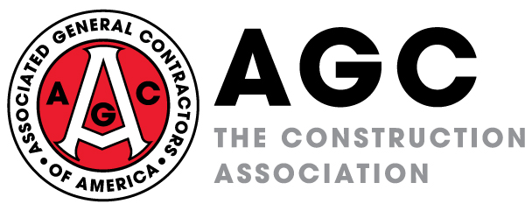

MEDIA TIPS FOR THE CORONAVIRUS SAFETY STAND DOWN

Thank you for agreeing to allow media to come and cover your coronavirus safety stand down. To follow are some general tips for working with the media while they are on your job site. In addition to these general do’s and don’ts, please feel free to contact Brian Turmail at brian.turmail@agc.org or 703-459-0238 with any questions or concerns.

Do’s

- Remember the stand down is for your workers. Focus on them and let the media cover that. Don’t spend your time staging for the media.

- Have someone on standby to escort the media the entire time they are on your project.

- Provide them with new, wrapped PPE they may be required to wear on a project. Avoid previously-used equipment because of the coronavirus.

- Tell them where they can set up and operate. And, tell them what is off limits for safety reasons and why.

- Understand while they are on your site, everything is “on the record.”

- Be willing to make someone, like a safety director, available to speak with the media one-on-one after the stand down is over.

- Remember to have someone take pictures of your stand downs and the media on site. Send your pictures to brian.turmail@agc.org.

Don’ts

- Let them operate in a way that compromises theirs, or your, safety.

- Let them wander around un-escorted, given the safety risks associated with project sites.

- Respond to a question you don’t know the answer to. If they ask a question you don’t know the answer to, be honest and tell them you don’t know.

- Assume they know what they are seeing. Someone at your project will need to explain to them what is happening at your stand down, why it is important and how it will help.

- Forget to give them a name and number to call if they have questions after they leave. Otherwise, they are likely to get important details wrong as they edit their story.

