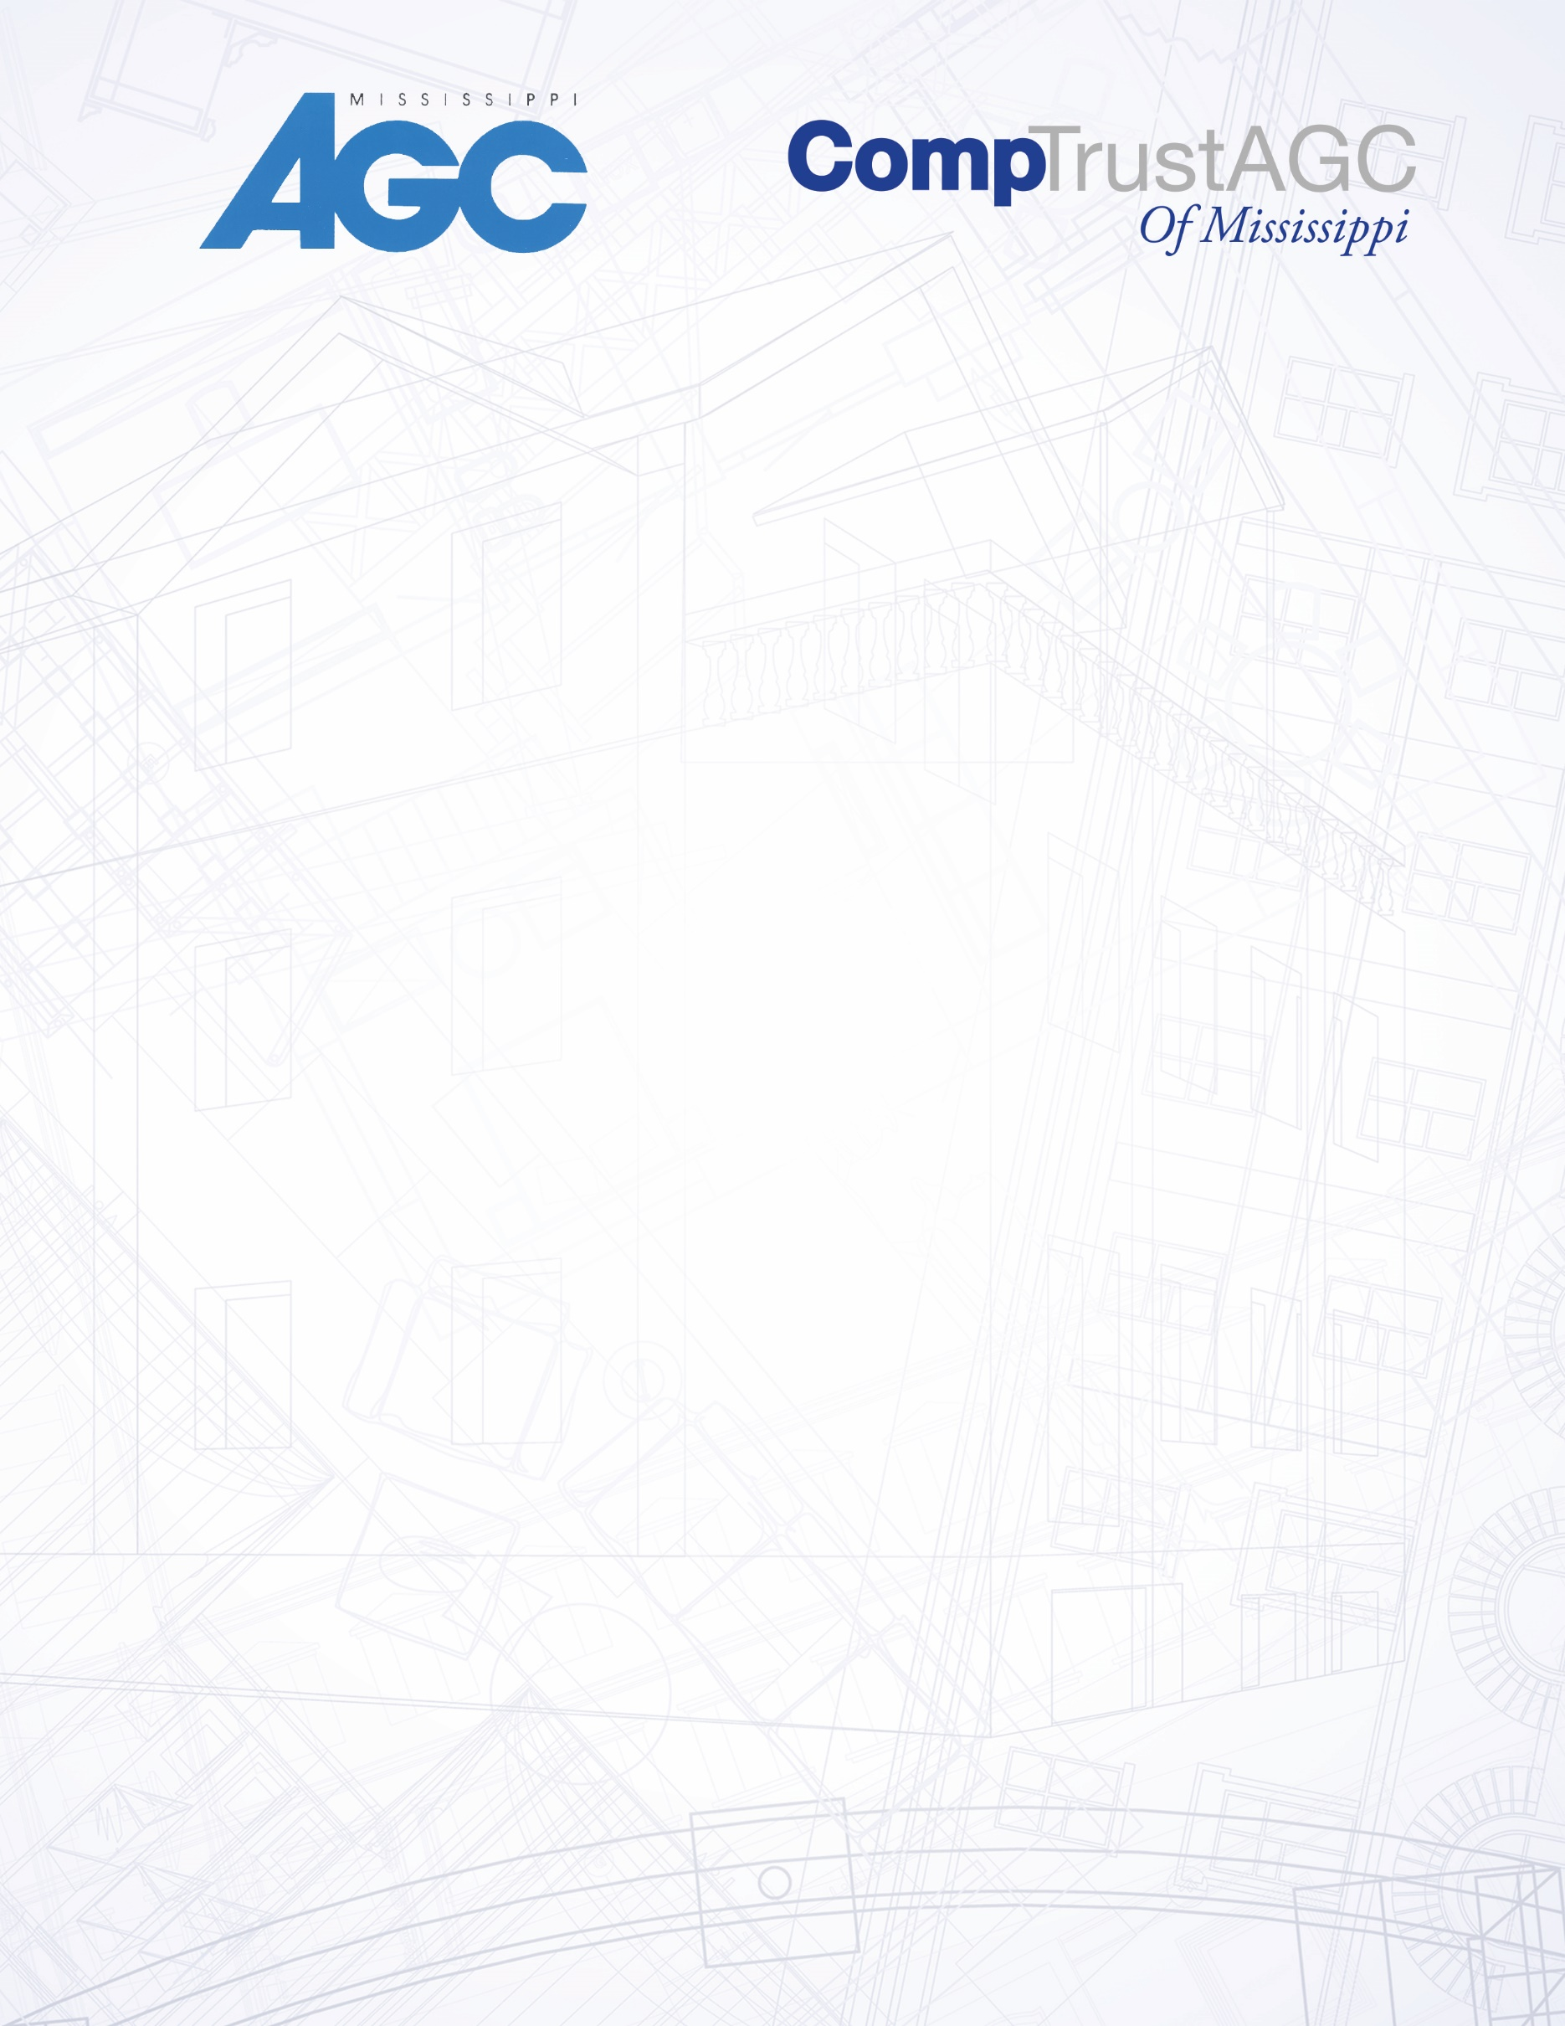

Gulfport

February 2- Session 1

February 9- Session 2

February 16- Session 3

February 23- Session 4

April 6- Session 1

April 13- Session 2

April 20- Session 3

April 27- Session 4

July 6- Session 1

July 13- Session 2

July 20- Session 3

July 27- Session 4

September 7- Session 1

September 14- Session 2

September 21- Session 3

September 28- Session 4

November 2- Session 1

November 9- Session 2

November 16- Session 3

November 30- Session 4

**OSHA 30 Dates for 2017**

Jackson

January 5- Session 1

January 12- Session 2

January 19-Session 3

January 26- Session 4

March 2- Session 1

March 9- Session 2

March 16- Session 3

March 23- Session 4

May 4- Session 1

May 11- Session 2

May 18- Session 3

May 25- Session 4

August 3- Session 1

August 10- Session 2

August 17- Session 3

August 24- Session 4

October 5- Session1

October 12- Session 2

October 19- Session 3

October 26- Session 4

Call AGC Mississippi at 601.981.1144

Or email [carl@msagc.com](mailto:carl@msagc.com) to reserve space.

AGC of Mississippi now offers the OSHA 10 & 30Hour safety training in a new more flexible format. Employees may select the days they will be able to Attend the class and will have 5 months (20 classes)To complete the required sessions. Participants Select their training days and attend those classes. Participants may take the sessions in sequence or mix and match. Classes are held on Thursdays.

OSHA 30 hour sessions 1,2, and 3 MUST be completed before enrolling in session 4. OSHA 10 Participants enroll in

One full day and one half day class. OSHA 30 participants enroll in four (4) full day sessions.

Fees for OSHA 10 are $100 for members, $175 for nonmembers and **FREE for CompTrust AGC Members.**

Fees for OSHA 30 are $250 members and $300 for nonmembers and **FREE for CompTrust AGC Members.**