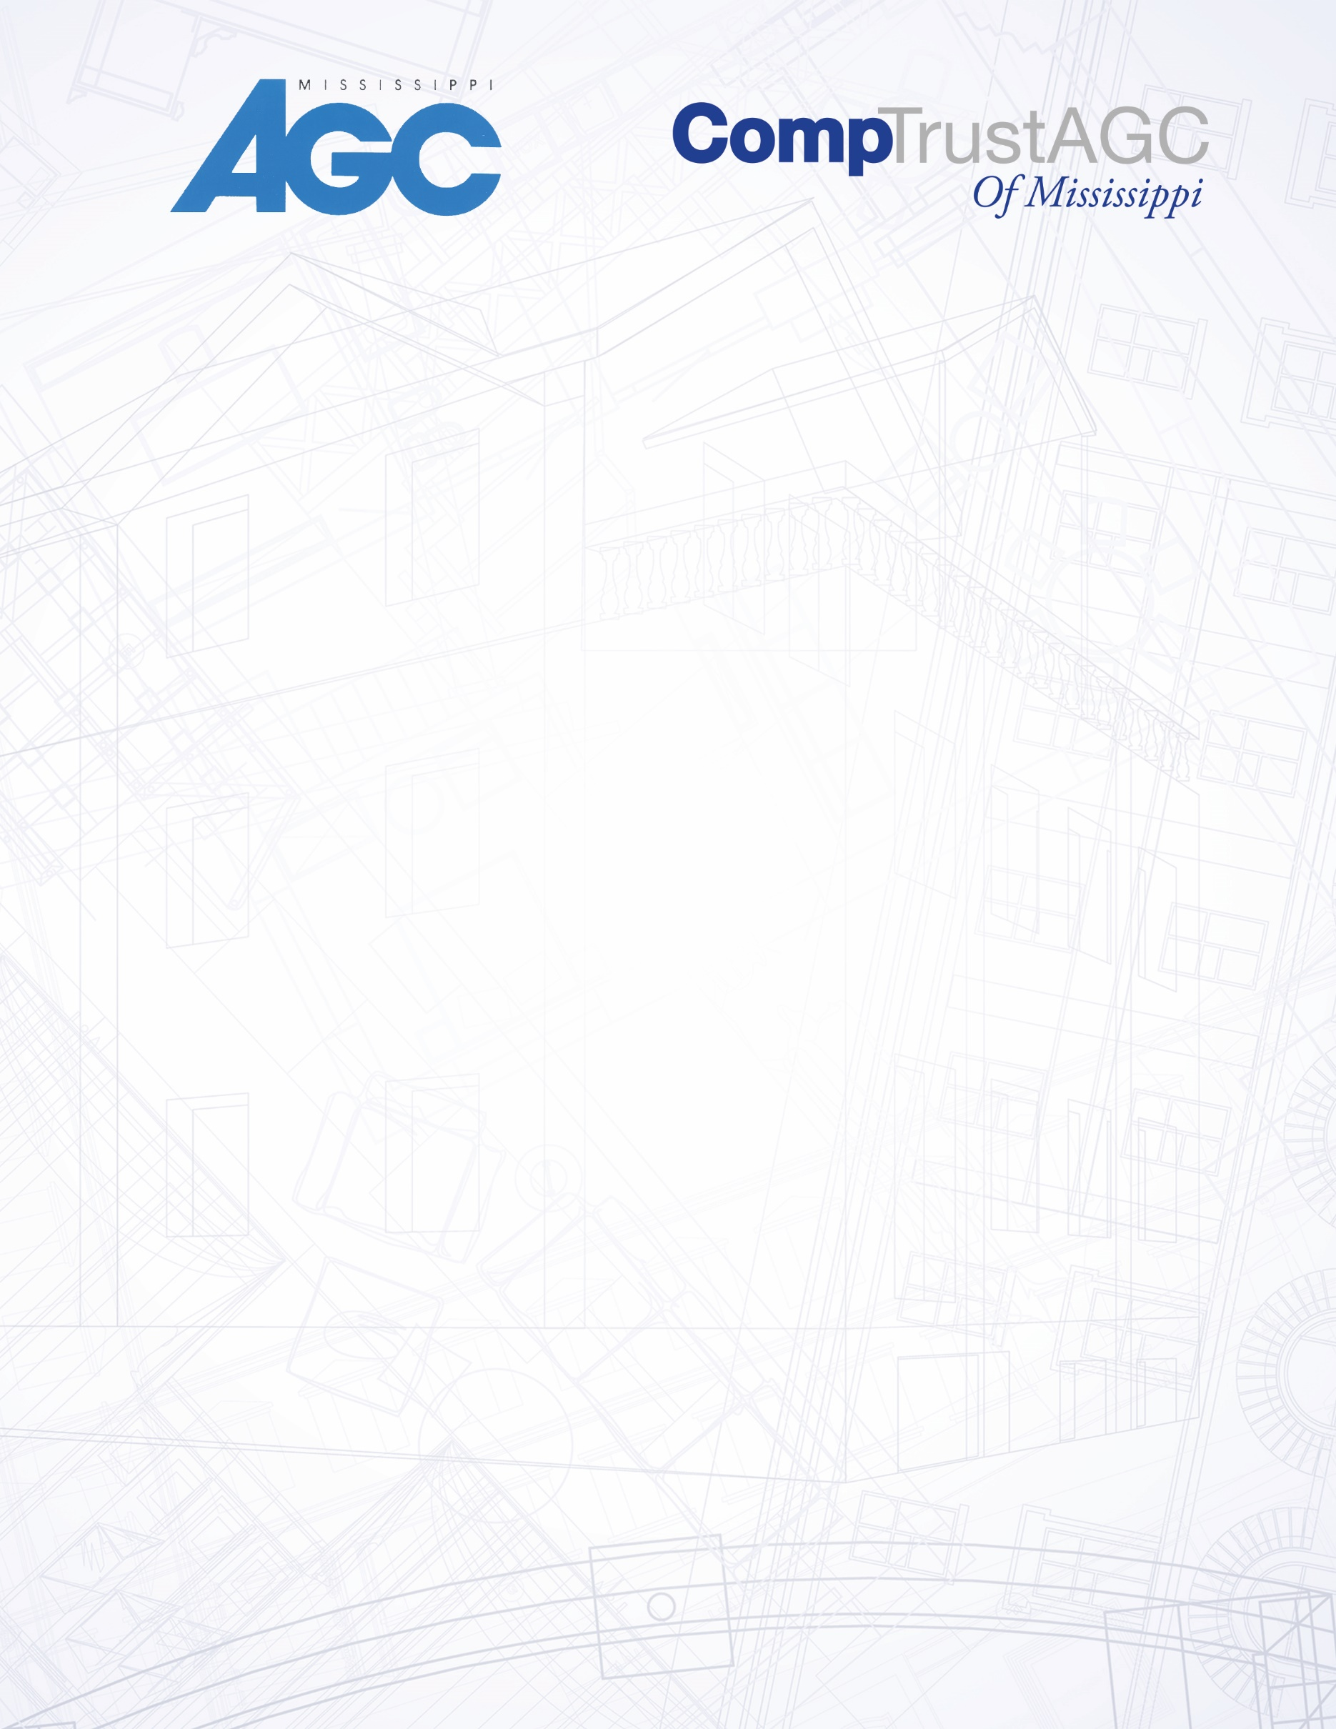

AGC of Mississippi now offers the OSHA 10 & 30Hour safety training in a new more flexible format. Employees may select the days they will be able to Attend the class and will have 5 months (20 classes) To complete the required sessions. Participants Select their training days and attend those classes. Participants may take the sessions in sequence or mix and match. Classes are held on Thursdays.

OSHA 30 hour sessions 1,2, and 3 MUST be completed before enrolling in session 4. OSHA 10 Participants enroll in one full day and one half day class. OSHA 30 participants enroll in four (4) full day sessions.

Fees for OSHA 10 are $100 for members, $175 for nonmembers and **FREE for CompTrust AGC Members.** Fees for OSHA 30 are $250 members and $300 for nonmembers.

***Class minimum size is three persons.***

**OSHA 10 dates for 2017**

Full Day: 7:30 – 4:30 Half Day: 7:30 -10:30

Call AGC Mississippi to register: 601.981.1144

or Email Carl@msagc.com

**Jackson:**

January 5-Full Day

January 12-Half Day

March 2-Full Day

March 9-Half Day

May 4-Full Day

May 11- Half Day

August 3- Full Day

August 10- Half Day

October 5- Full Day

October 12- Half Day

**Gulfport:**

February 2-Full Day

February 9-Half Day

April 6-Full Day

April 13-Half Day

July 6-Full Day

July 13-Half Day

September 7-Full Day

September 14-Half Day

November 2-Full Day

November 9-Half Day